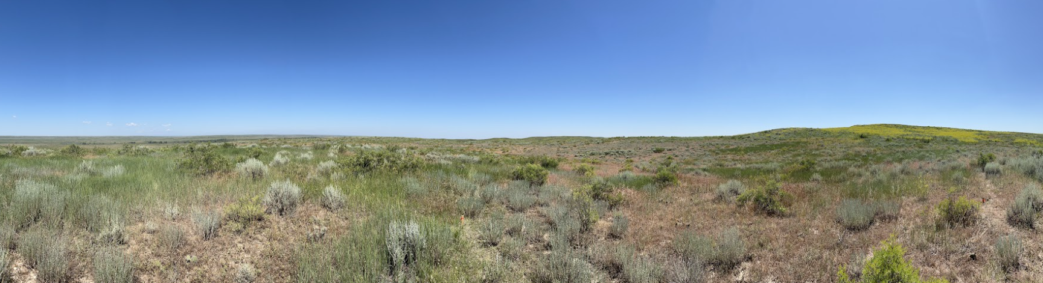

Avian, Pollinator, and Vegetation Technician Positions - Summer 2025

This position will assist a PhD student, Anna Freundlich, with her research studying how the vegetation, avian, and pollinator communities are affected by Indaziflam (herbicide) treatments in the Charles M. Russell wildlife refuge. Specific work duties will vary throughout the season, but the technician will need to work outside in harsh conditions including extreme sun and heat, biting insects, and they should expect to hike several miles per day in uneven terrain. Trailer housing is provided during work hitches. The technician may stay there for the duration of their employment, including breaks if they choose to do so. This position is perfect for students who want to be introduced to fieldwork. If applicants can only work during part of the season, they will be considered on a case-by-case basis. Hard-working, detail-oriented individuals who like being outdoors are strongly encouraged to apply!

Since this position is starting near the end of May, interested applicants should email their resume to [anna.freundlich@gmail.com](mailto:anna.freundlich@gmail.com) as soon as possible. Applications will be reviewed on a rolling basis.

Required Qualifications:

* Be willing and able to hike up to 10 miles/day while carrying a heavy pack.
* Able to work up to 10-hour days.
* Can tolerate intense sun, biting insects, and working outdoors for extended periods of time.
* Will follow and adhere to scientific protocols accurately and consistently.
* Must be able to work an irregular work schedule; roads in this part of the state are impossible to drive on when it rains, so the technician must be available when roads are passable.

First Half of Season: ~ May 21 – June 20

The technician for this half of the season will focus on collecting avian point-count data and pollinator sampling. The technician will help with recording presence/absence data of birds via point counts, autonomous recorder setup and collection, and pollinator sampling setup and collections.

Preferred Qualifications:

* Ornithology coursework and/or previous ornithology research experience
* Previous general research or field technician experience.

Second Half: ~ June 25 – August 8

The technician will focus on collecting structural vegetation data and pollinator sampling for the latter part of the season. The technician will collect structural vegetation data including recording vegetation height, vegetation gaps, and collecting plot photos. The technician will also assist with pollinator sampling setup and collections.

Preferred Qualifications:

* Botany and Plant ID coursework and/or previous botany research experience
* Previous general research or field technician experience